HTML Project

A

PROJECT REPORT

ON

**“Hospital website ”**

By

Suhas Vitthal kale.

Abhishek sahadev Koli

Kausif Ayyaz pathan

Pratik satish ganbawale

Under the guidance of

Mrs. V. V. Sunke

Through

The Principal Of G. A. C. C. Sangli

For the partial fulfillment of the BACHELOR OF COMPUTER APPLICATION



Latthe Education Society’s

Ganpatrao Arwade College of Commerce, Sangli.

2022-23



Latthe Education Society’s

Ganpatrao Arwade College of Commerce, Sangli.

### Certificate

This is to certify that, the project report entitled **Hospital website** is record of project work, carried out in this college by **Mr.Suhas Vitthal kale, Mr.Abhishek sahadev Koli ,Mr. Kausif Ayyaz pathan ,Mr. Pratik satish ganbawale** , of Bachelor Computer Application as laid down by Latthe Education Society’s Ganpatrao Arwade College of Commerce, Sangli.

during the year 2022-23.

This project their sincere work carried out under Guidac Mrs. V. V. Sunke .

Mrs. V. V. Sunke Examiner

(Project Guide)

## DECLARATION

This is to certify that project report entitled “Hospital Website .”

Submitted to Shivaji University, Kolhapur in partial fulfillment of the requirement for the award of the degree of BACHELOR OF COUMPUTER APPLICATION (B.C.A.)

sem-IV is an original work carried out.. The matter embodied in the project is authentic and is genuine work done by us and has not been submitted whether to this University or to any other University/Institute for the fulfillment of the requirement for any course of study.

|  |  |  |
| --- | --- | --- |
| Roll  .no | Names | Sign |
| 5818 | Kausif Ayyaz pathan |  |
| 5821 | Abhishek sahadev Koli |  |
| 5832 | Pratik satish ganbawale |  |
| 5856 | Suhas Vitthal kale. |  |

Place: Sangli

Date:

###### ACKNOWLEDGEMENT

I would like thanks to all those who are involved in this endeavor for their kind cooperation for its successful completion. At the outset, I wish to express our sincere gratitude to all those people who helped me to complete this project in an efficient manner.

I offer my special thanks to my project Gidance , Professor, without whose help and support throughout this project would not have been this success. His guidance helped me in all the time of my project and writing of this project report.

Also I would like to thanks to my project Guide Mrs. V. V. Sunke .Lecture, who gave opportunity to do this project at an extreme organization and also help me to complete this project. Most of all and more than ever, we would like to thanks my family member for their warmness, support, kindness and patience.

We are really thankful to all of my friends who always advised and motivated me throughout the course.

**Index**

|  |  |  |
| --- | --- | --- |
| **Sr. No.** | **Topic** | **Page No.** |
|  | **Introduction** | **6** |
|  | **Introduction to html & scripting** | 1. **8** |
|  | **Objective & Scope** | **9** |
|  | **System Requirement** | **10** |
|  | **Site Map** | **11 - 13** |
|  | **System Analysis** | **14 - 15** |
|  | **System Design** | **16 - 18** |
|  | **System Testing** | **19 - 20** |
|  | **User Interface** | **11 - 25** |
|  | **Conclusions** | **26** |
|  | **Reference** | **27** |

**Introduction**

Human Body is a very complex and sophisticated structure and comprises of millions of functions. All these complicated functions have been understood by man him, part-by-part their research and experiments. As science and technology progressed, medicine became an integral part of the research. Gradually, medical science became an entirely new branch of science. As of today, the Health Sector comprises of Medical institutions i.e. Hospitals, HOSPITALS etc. research and development institutions and medical colleges. Thus the Health sector aims at providing the best medical facilities to the common man

**Problem Statement**

Since Hospital is associated with the lives of common people and their day-to-day routines so I decided to work on this project.

The manual handling of the record is time consuming and highly prone to error. The purpose of this project is to automate or make online, the process of day-to-day activities like Room activities, Admission of New Patient, Discharge of Patient, Assign a Doctor, and finally compute the bill etc. I have tried my best to make the complicated process Hospital Management System as simple as possible using Structured & Modular technique & Menu oriented interface. I have tried to design the software in such a way that user may not have any difficulty in using this package & further expansion is possible without much effort. Even though I cannot claim that this work to be entirely exhaustive, the main purpose of my exercise is perform each Hospital's activity in computerized way rather than manually which is time consuming.

I am confident that this software package can be readily used by non-programming personal avoiding human handled chance of error.

**INTRODUCTION TO HTML & SCRIPTING**

**HTML**

“ HTML ”, or “Hypertext Markup Language” is designed to specify the logical organization of a document, with important hypertext extensions. This choice was made because the same HTML document may be viewed by many different “browsers” , of very different abilities. Thus, for example, HTML allows you to mark selections of text as titles or paragraphs, and then leaves the interpretation of these marked elements up to the browser. For example one browser may indent the beginning of a paragraph, while another may only leave a blank line.

HTML instructions divide the text of a document into blocks called elements.

These can be divided into two broad categories—those that define how the BODY of the document is to be displayed by the browser and those that define

information ‘about’ the document, such as the title or relationships to other documents. The vocabulary of these elements and a description of the overall design of HTML documents is given in the rest of section. 2.the last part of the section also describes standard naming schemes for HTML documents and related files.

The detailed rules for HTML (the names of the tags/elements, how they can be used) are defined using another language known as the standard generalized markup language, or SGML. Fortunately , HTML is much simpler.

SCRIPTING:

**“*Java Script****”* is an object oriented scripting language used in webpage to perform

Task validation of data, processing of number& modification of form it is an interpreted language means its code is executed without preliminary compilation. This script is executed by compatible browser. The JavaScript is embedded in HTML or can be written in separate file JavaScript developed by breedeach form Netscape communication in early 1996. Java& JavaScript are two completely different languages.

* Java developed by sum microsystem is a powerful & complex programing language. JavaScript firstly supported by Netscape navigator browser.
* JavaScript is client side scripting language designed adding some features to html pages. The structure of JavaScript is

1. The <script> tag is used to include Java Script into HTML page.
2. Languages attribute is used to inform the browser about the scripting language being used in JavaScript.
   * The file containing JavaScript will be saved with extension.HTML.
3. JavaScript is only scripting language supported by web browsers.
4. JavaScript is made up of executable computer code.
5. Everyone can use JavaScript without purchasing a license.

**Objective & Scope**

**Objective**

Hospital are the essential part of our lives, providing best medical facilities to people suffering from various ailments, which may be due to change in climatic conditions, increased work-load, emotional trauma stress etc. It is necessary for the hospitals to keep track of its day-to-day activities & records of its patients, doctors, nurses, ward boys and other staff personals that keep the hospital running smoothly & successfully.

But keeping track of all the activities and their records on paper is very cumbersome and error prone. It also is very inefficient and a time-consuming process Observing the continuous increase in population and number of people visiting the hospital. Recording and maintaining all these records is highly unreliable, inefficient and error-prone. It is also not economically & technically feasible to maintain these records on paper.Thus keeping the working of the manual system as the basis of our project. We have developed an automated version of the manual system, named as “Administration support system for medical institutions”.

The main aim of our project is to provide a paper-less hospital up to 90%. It also aims at providing low-cost reliable automation of the existing systems. The system also provides excellent security of data at every level of user-system interaction and also provides robust & reliable storage and backup facilities.

**Scope**

The proposed software product is the Hospital Management system (HMS). The system will be used in any hospital, clinic, dispensary or pathology labs. Clinic, dispensary or pathology to get the information from the patients and then storing that data for future usages. The current system in use is a paper based system. It is too slow and cannot provide updated lists of patients within reasonable timeframe. The intention of the system is to reduce over-time pay and increase the number of patients that can be treated accurately. Requirement statements in these documents are both functional and non-functional.

## **System Requirement**

**Product Functions**

* **Hardware Requirements**

1. A device (Computer/laptop)
2. Memory (RAM): Minimum 2GB RAM
3. Processor: Minimum 1GHZ; Recommended 2GHZ or more.
4. Hard disk – 40 GB; Recommended 64 GB or more.
5. Ethernet connection (LAN) or, a wireless adapter (Wi-Fi)

* **Software Requirements**

1. A database like DBMS to store the list of authors and the articles.
2. A web browser like Chrome, Mozilla Firefox etc.
3. Operating System – Windows, Linux, macOS 32 bit and 64 bit

**Site Map**

1. **Booking an appointment**

Description - Patients who want to make an appointment at the hospital must describe their health problem in detail, and a specialised doctor will be assigned to them based on their medical condition/disease.

**Diagnosis of disease**

Input: Patient’s symptoms in details

Output: Specialized doctor suggested for the disease.

**Booking a slot**

Input: Specialized doctors searched on the basis of their time of availability

Output: Appointment Id generated along with time slot

**Online payment**

Description - Patients can pay online or offline, depending on their preferences. They must choose a specific payment gateway to pay online in the HMS, and a payment receipt will be provided upon successful payment.

Input: Patient asked to choose their preferred payment gateway and enter details.

Output: Payment receipt generated

1. **Viewing health records**

Description - Patients once logged in with their respective patient ids will be able to see health records like - Hospitalization, Test Reports, Doctor Consultations etc.

**Hospitalization**

Input: Patients can choose to see hospitalization details, test reports, prescription etc. Output: The respective information showed to the patient.

**Test Reports**

Input: Patients can upload test reports for ease of consultation.

Output: Respective doctor mapped with the patient Id gets the test report.

**Doctor Consultation**

Input: Patients can upload prescriptions obtained from consultation with previous doctor Output: Respective doctor mapped with the patient Id gets the previous prescriptions.

1. **Viewing health records**

Description - Patients once logged in with their respective patient ids will be able to see health records like - Hospitalization, Test Reports, Doctor Consultations etc.

**Hospitalization**

Input: Patients can choose to see hospitalization details, test reports, prescription etc. Output: The respective information showed to the patient.

**Test Reports**

Input: Patients can upload test reports for ease of consultation.

Output: Respective doctor mapped with the patient Id gets the test report.

**Doctor Consultation**

Input: Patients can upload prescriptions obtained from consultation with previous doctor Output: Respective doctor mapped with the patient Id gets the previous prescriptions.

1. **Ordering online medicines**

Description - Patients who want to order medicines from hospital can upload (Required) or select their prescription from health records and on verification of that prescription medicines will be delivery to the patient

**Verification of prescription**

Input: Patient asked to upload new prescription/select their prescription from health record. Output: Verification of prescription

**Ordering medicines**

Input: Medicines required

Output: Order from patient taken and based on medicine availability order id generated.

**Online payment ( Medicines )**

Description - Patients have the choice to pay online/offline according to their convenience. For paying online in the HMS, they have to choose a specific payment gateway and on successful payment, payment receipt will be generated. Input: Patient asked to choose their preferred payment gateway and enter details. Output: Payment receipt generated

1. **Emergency admission**

Description - Admission of a patient in case of medical emergency and identification of the medical condition and specialized doctor along with ICU/CCU allocated according to availability.

**Registration of patient**

Input: User needs to sign in/sign up depending on whether he/she is new/existing user Output: Patient ID generated/patient details fetched from existing database

**Identification of Medical Emergency**

Input: The medical condition identified according to the symptoms.

Output: Patient allocated to available ICU/CCU along with specialized doctor according to availability.

1. **Discharge and settlement of bills:**

Description - Deals with discharge of patients and Mediclaim related issues.

**Settlement of bills**

Input: Patient ID to fetch all expenses incurred starting from date of admission till current date

Output: Bill generated and handed over to patient for payment

**Discharge**

Input: Patient Id to check whether bill has been settled

Output: Patient discharged/checks-out with a discharge certificate

**System Analysis**

**Background Study**   
System Analysis is a separation of a substance into parts for study and their implementation and

detailed examination. Before designing any system it is important that the nature of the business and the way it currently operates are clearly understood. The detailed examination provides the specific data required during designing in order to ensure that all the client's requirements are fulfilled. The investigation or the study conducted during the analysis phase is largely based on the feasibility study. Rather it would not be wrong to say that the analysis and feasibility phases overlap. High-level analysis begins during the feasibility study. Though analysis is represented as one phase of the system development life cycle (SDLC), this is not true. Analysis begins with system initialization and continues until its maintenance. Even after successful implementation of the system, analysis may play its role for periodic maintenance and up gradation of the system. One of the main causes of project failures is inadequate understanding, and one of the main causes of inadequate understanding of the requirements is the poor planning of system analysis.

**Software system attributes**

**Reliability:** This application is a reliable product that produces fast & verified output of all its

process.

**Availability:** This application will be available to use and help them to carry their operations

conveniently.

**Security:** This application will be designed in a maintainable manner. It will be easy to

incorporate new requirements in the individual modules.

**Scope of working:**

The proposed software product is the Hospital Management system (HMS). The system will be used in any hospital, clinic, dispensary or pathology labs. Clinic, dispensary or pathology to get the information from the patients and then storing that data for future usages. The current system in use is a paper based system. It is too slow and cannot provide updated lists of patients within reasonable timeframe. The intention of the system is to reduce over-time pay and increase the number of patients that can be treated accurately. Requirement statements in these documents are both functional and non-functional

**System Design**

**Database Design**

Database design is the process of producing a detailed data model of database. This data model contains all the need logical and physical design choices and physical storage parameters needed to generate a design in a data definition language, which can then be used to create a database. A fully attributed data model contains detailed attributes for each entity.

The term database design can be used to describe many different part of the design of an overall database system. Principally, and most correctly, it can be thought of as the logical design of the base data structure used to store the data. In the relational model these are the tables and views. In an object database the entities and relationships map directly to object classes and named relationships. However, the term database design could also be used to apply to the overall process of designing, not just the base data structure, but also the forms and queries used as part of the overall database application within the database management system.

1. **R Diagram of Hospital Management System**

An entity-relationship diagram (ERD) is an abstract and conceptual representation of data. Entity-relationship modeling is a database modeling method, used to produce a type of conceptual schema or semantic data model of a system, often a relational database, and its requirements in a top-down fashion.

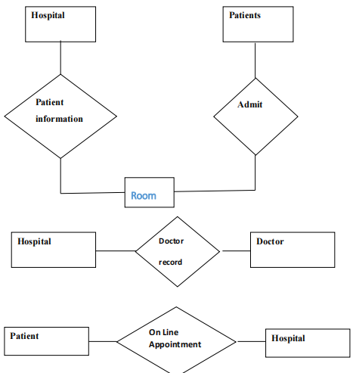

**E-R Diagram of Online Marketplace**

**Database schema of Hospital Management System**

A database schema is the skeleton structure that represents the logical view of the entire database. It defines how the data is organized and how the relations among them are associated. It formulates all the constraints that are to be applied on the data.

A database schema can be divided broadly into two categories −

**Physical Database Schema:** This schema pertains to the actual storage of data and its form of storage like files, indices, etc. It defines how the data will be stored in a secondary storage

**Logical Database Schema:** This schema defines all the logical constraints that need to be applied on the data stored. It defines tables, views, and integrity constraints.

**List of table:**

1.admin

2.Users

3.Patients

4.Physician

5.Services

6.Transactions

7.user_details

8.Room

9.Discounts

10.Appointment

11.Doctors

12.Doctor specialization.

**System Testing**

**Integration Testing**

Integration testing done before, during and after integration of a new module into the main software package. This involves testing of each individual code module. One piece of software can contain several modules which are often created by several different programmers. It is crucial to test each modules effect on the entire program model. After integration testing the project works successfully.

**Unit Testing**

Unit testing performed on each module or block of code during development. Unit testing is

normally done by the programmer who writes the code.

**System Testing**

System testing done by a professional testing agent on the completed software product before it is introduced to the market**.**

**Functional Testing**

Functional Testing also known as functional completeness testing. Functional Testing involves trying to think of any possible missing functions. Testers might make a list of additional functionalities that a product could to improve it during functional testing.

**Hardware/Software Testing**

Hardware/Software testing as “HW/SW Testing”. This is when the tester focuses his attention on the interactions between the hardware and software during system testing.

**Security Testing**

Security Testing is a variant of Software Testing which ensures, that system and applications in an organization, are free from any loopholes that may cause a big loss. Security testing of any system is about finding all possible loopholes and weaknesses of the system which might result into a loss of information at the hands of the employees or outsiders of the Organization

**Advantages**

The software helps to handle the entire administration of hospitals and healthcare facilities.

Typically, such a software includes various modules that help doctors manage their assignments and schedules, carry out patient registration, maintain store inventory records, keep track of medicine, administration, maintain blood bank (with available blood type) details, individual record of patients with their test reports, nursing and housekeeping service details, financial information, including final billing & payments, insurance details and much more. After the customized software is implemented and integrated into the system, patient care and hospital administration becomes an easy job.

**User Interface Output’s**

1. **Home Page**

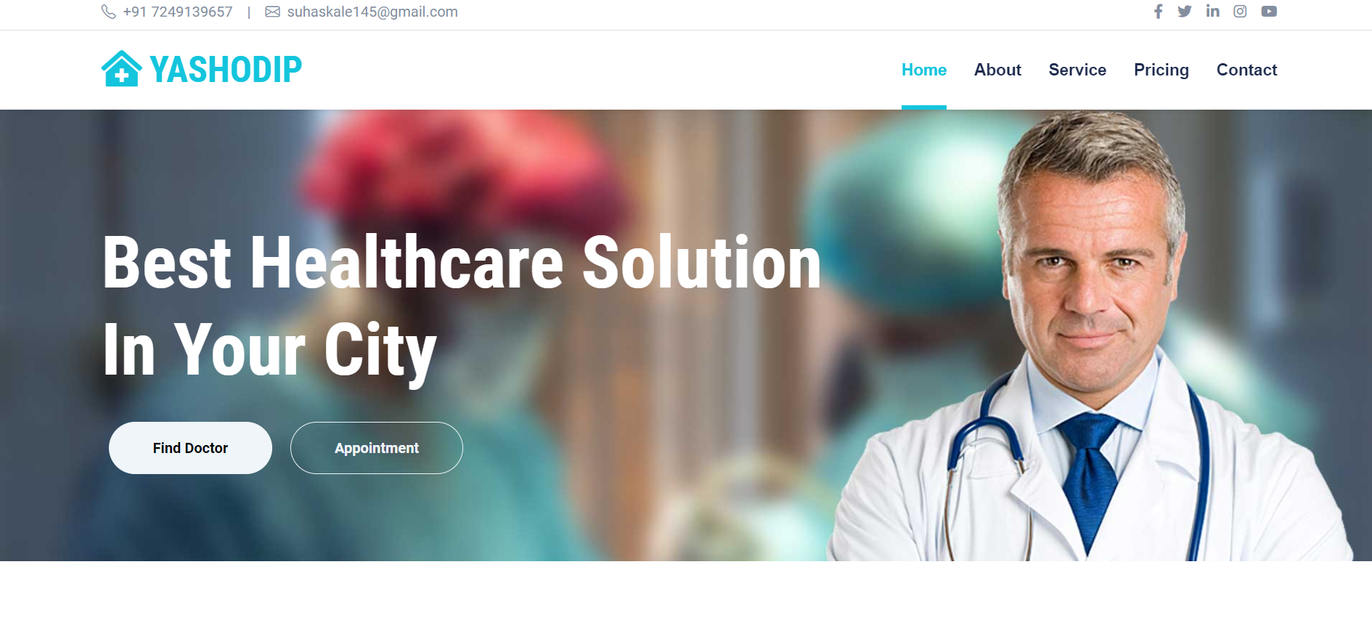

1. **About Us**

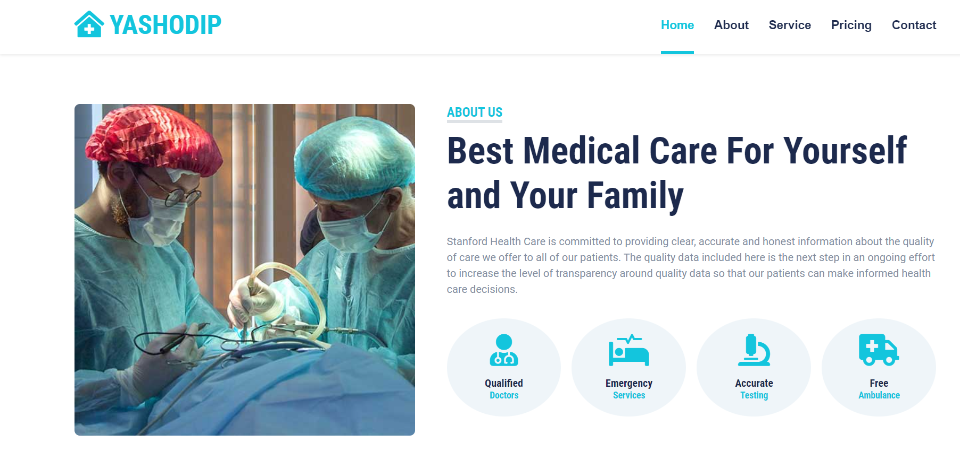

1. **APPOINTMENT**

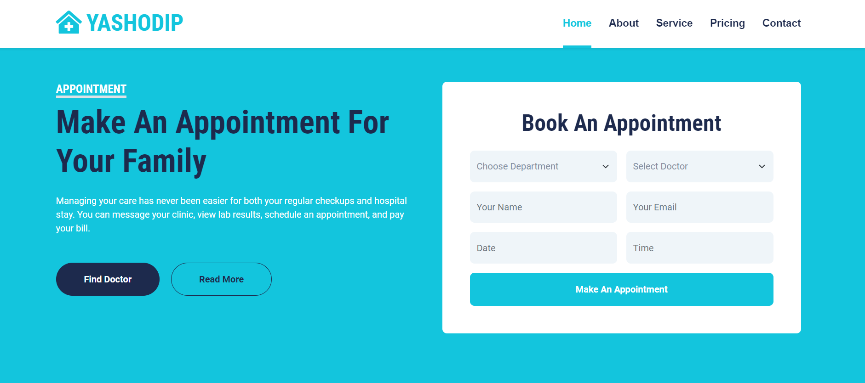

1. **Pricing**

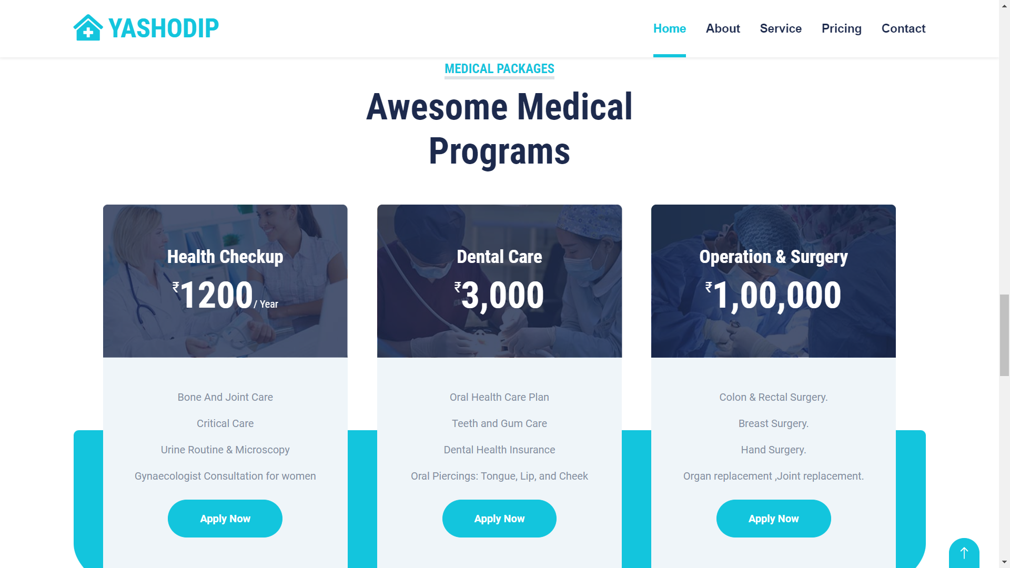

1. **OUR DOCTORS**

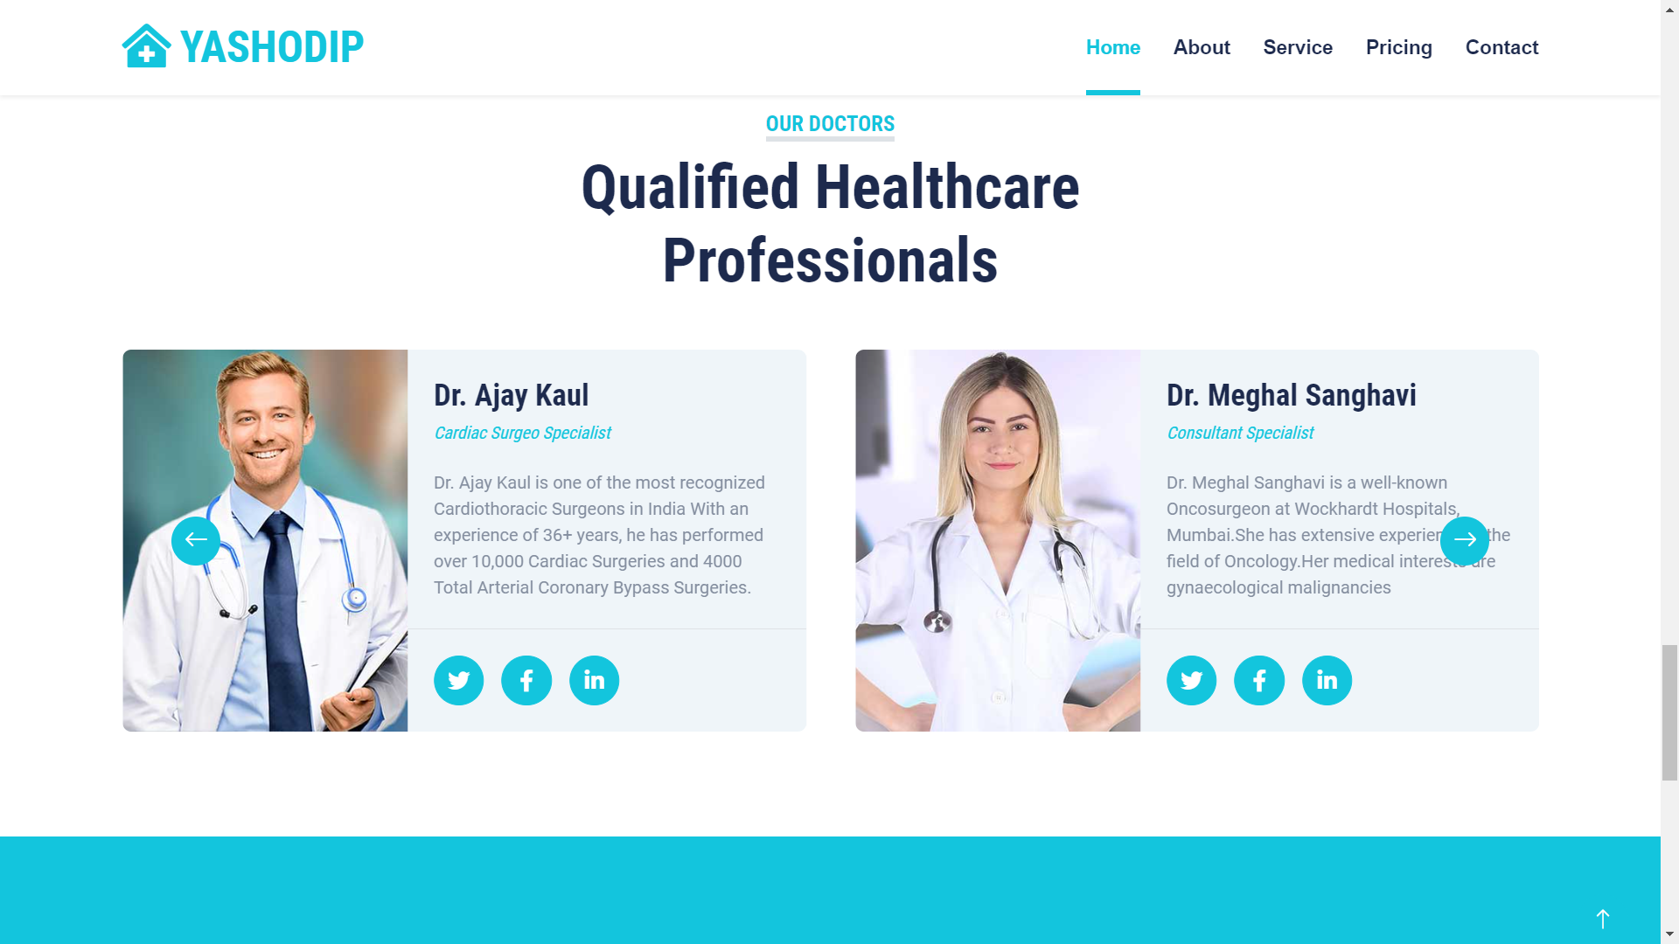

**Conclusions**

This project has been a rewarding experience in more than one way. The entire project work has enlightened us in the following areas.

a) We have gained an insight into the working of the HOSPITAL. This represents a typical real world situation.

b) Our understanding of database design has been strengthened this is because in order to generate the final reports of database designing has to be properly followed.

c) Scheduling a project and adhering to that schedule creates a strong sense of time management.

d) Sense of teamwork has developed and confidence of handling real life project has increased to a great extent.

e) Initially, there were problem with the validation but with discussions, we were to implement validations.

**References**

* **<https://kingswayhospitals.com>**
* **<https://www.jupiterhospital.com>**
* **[https://www.google.com/search?q=hospital+website&rlz=1C1ONGR_enIN1049IN1049&sxsrfm](https://www.google.com/search?q=hospital+website&rlz=1C1ONGR_enIN1049IN1049&sxsrf=APwXEdf5obMMUKr8urHzIJzFkXAefE8SBg:1684692178059&source=lnms&tbm=isch&sa=X&ved=2ahUKEwjr0dC2_4b_AhWCzDgGHXngAF0Q_AUoAXoECAEQAw&biw=1536&bih=746&dpr=1.25#imgrc=SZjynXpCcyuzbM)**
* **<https://www.similarweb.com>**
* **<https://www.vaidam.com>**